- Implement and demonstrate Find S algorithm for finding the most specific hypothesis based on giving sets of training data samples

CODE:

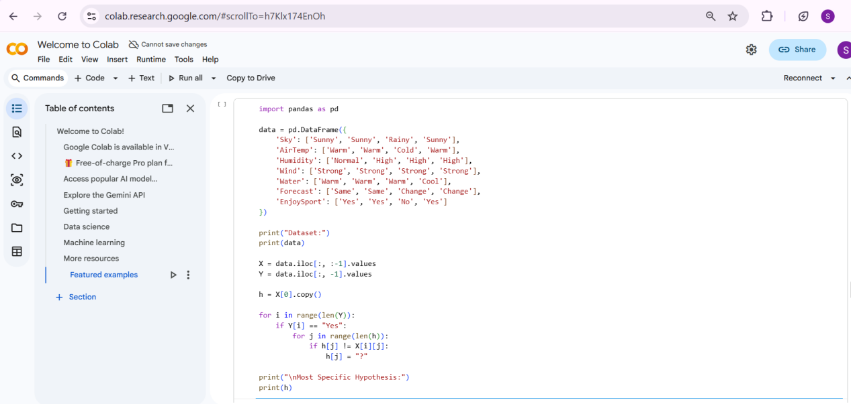

OUTPUT:

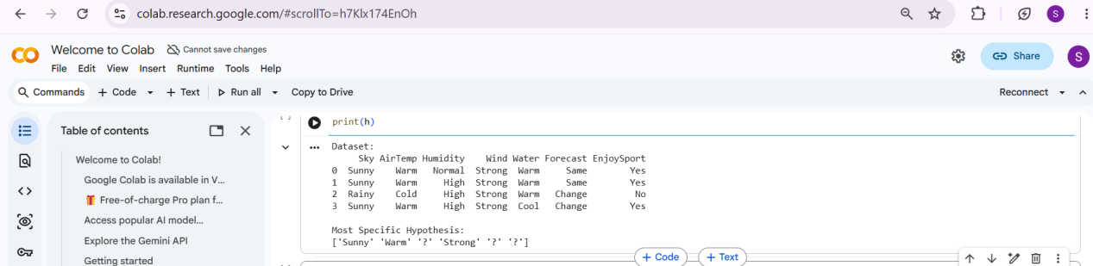

- For given set of training data examples stored in csv file, implement and demonstrate the candidate elimination algorithm in python to output a description of the set of all hypotheses consistent with training examples
CODE:
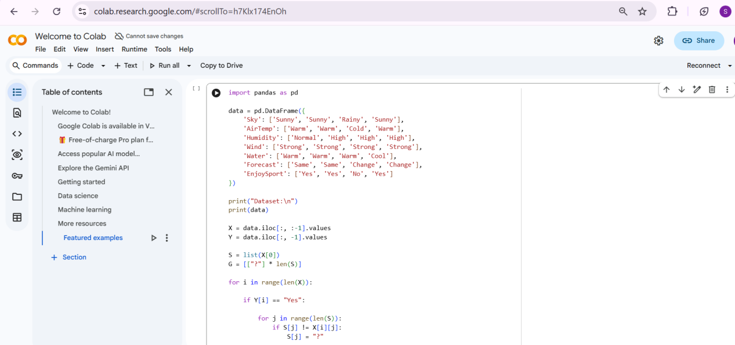

OUTPUT:

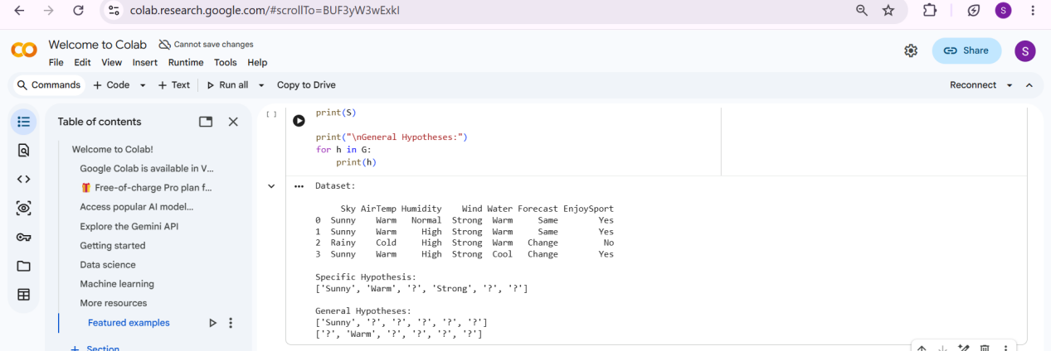

- Demonstrate working of the decision tree based on ID3 algorithm.

